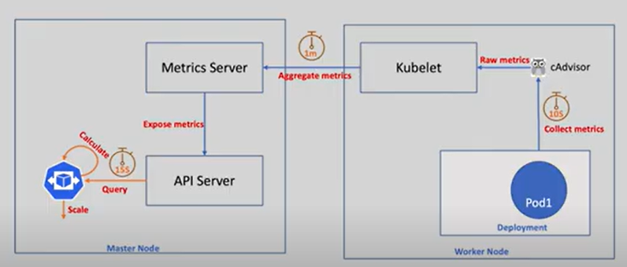

Formula



Example : ceil (2 * 90/70) = 3 replicas

1. Create Deployment
2. Create service
3. Create HPA
4. Ebable metric server

minikube addons enable metrics-server

kubectl top pods - to get the pod metrics

kubectl get hpa

kubectl describe hpa <hpa name>

1. Generate traffic using traffic generator

kubectl apply -f traffic-generator.yaml

1. Go into traffic generator pod using **exec**

kubectl exec -it traffic-generator – sh

use the http bench marking tool to generate traffic continuously

apt add wrk

run the following command

wrk -c 5 -t 5 -d 300s -H 'Connection: close' http://utility-api-service:9090/stress